PROGRAM DESCRIPTION

Program gives user opportunity to sort a list of numbers in specific way by selecting one of given sorting algorithms and types. First of all user should enter list of numbers dividing them by spaces. After that user may choose one of provided sorting algorithms and types (image 1). Default properties are quick sort algorithm and ascending type.

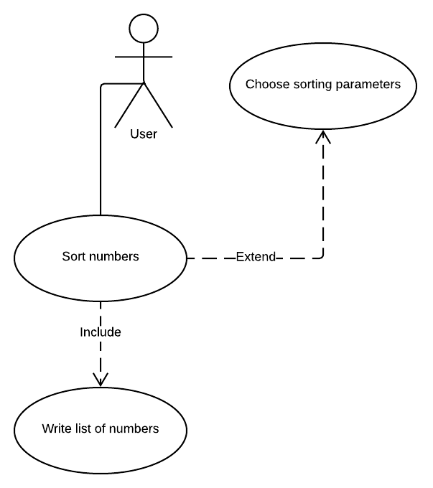

Image 1. Use Case diagram

Application enables sorting by any of following algorithms:

1. Selection sort.
2. Insertion sort.
3. Merge sort.
4. Quick sort (default).

It also provides possibility to choose one of those sorting types:

1. Ascending (default).
2. Descending.

After having the way of sorting chosen user has to press button to get sorted list of numbers and count of operations on the window. Sorted list is presented in the same way as entered one ­– divided by spaces, count of operations is placed near the sorted list.